HEATING AND COOLING

Heat and Temperature

• These are NOT the same.

Heat: the total of the potential and kinetic energy (internal energy) of the particles in a
substance.

Temperature: a measure of the average kinetic energy of the particles in a substance.

• The amount of heat held varies with the type of substance.

e.g. Metals hold quite a lot of heat, but water holds much more. Hence, it takes more heat to
change the temperature of the water than a metal.

Example

A group of students held a large metal nut in a Bunsen flame and heated it to red heat (~ 400 °C). They then placed it carefully into 50 mL of water at 20 °C. The water temperature rose only to
35 °C.

Hence the metal may have been much hotter in temperature but it didn't hold much heat as it only changed the water temperature by a small amount.

• Heat always flows from the higher temperature area to the lower temperature area.

e.g. Your hand is about 35 °C and a bench top is 20 °C. When you touch the bench, heat
flows from your hand into the bench until both are at the same temperature.

The bench feels cold as the heat is drawn out of your hand.
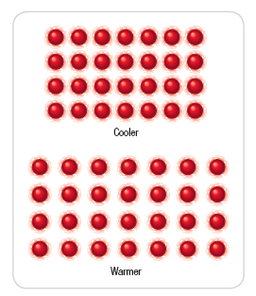
Thermal Energy

As heat is put into a substance, the particles move faster (which means it has more kinetic energy).

The average kinetic energy increases so the temperature is higher.

When a substance changes from a solid to a liquid (or gas), the particles move further apart (which means they have more potential energy).

